Photography Reflection: Camera Settings, Challenges, and Improvements
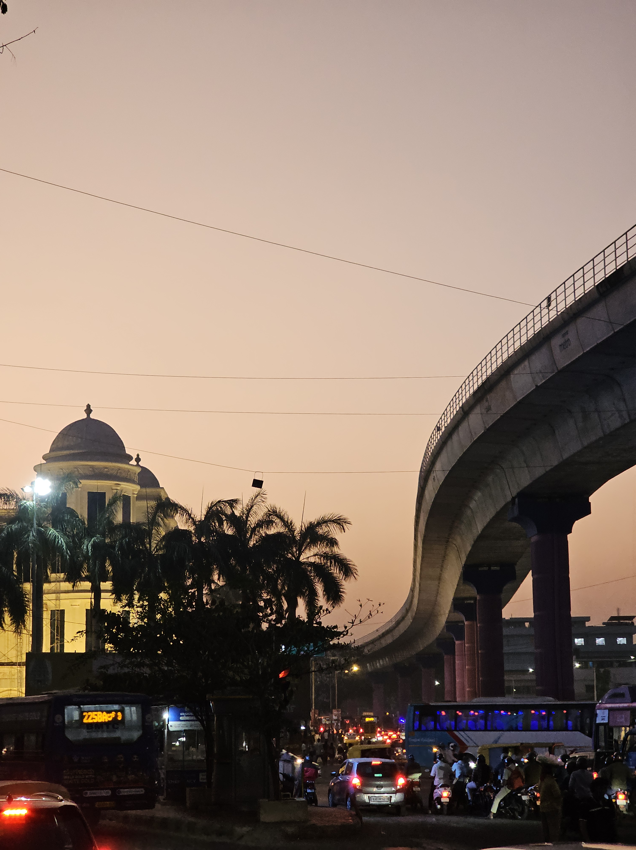

URBAN DUSK SCENE

This photograph captures a vibrant evening street scene beneath an elevated metro line, with warm dusk light in the sky and active city life below. The curved flyover, buses, vehicles, and pedestrians create strong visual movement, while the domed building and palm trees add architectural and cultural depth. The image effectively conveys the energy of an Indian city at twilight, blending motion, structure, and atmosphere.
A key challenge in this photograph is managing mixed lighting conditions. The sky retains soft pastel tones, while the street level is illuminated by artificial lights from vehicles and buildings. This high dynamic range makes exposure difficult. The camera appears to have balanced the sky well, but some shadow areas in the foreground are underexposed, reducing detail in vehicles and people. Using HDR mode or slightly increasing exposure while protecting highlights could help preserve both sky color and street detail.
Another challenge is motion control. The scene includes moving traffic and pedestrians, which introduces slight blur in parts of the frame. While this adds realism and a sense of rush, a faster shutter speed could freeze key subjects more clearly. Alternatively, intentionally using a slower shutter with stabilization could create controlled light trails, enhancing the cinematic feel.
Color temperature also plays an important role. The warm sky contrasts with cooler artificial lights, likely influenced by automatic white balance. Manually setting white balance or fine-tuning in post-processing could unify tones while maintaining contrast between natural and artificial light.
For improvement, using a tripod would allow lower ISO and longer exposure, reducing noise and increasing sharpness. Refining composition by slightly adjusting the angle to reduce clutter at the bottom could strengthen visual flow. With better exposure balance, controlled motion, and refined color handling, this photograph could become a powerful representation of urban life at dusk, much like the reflective approach demonstrated in the reference document

